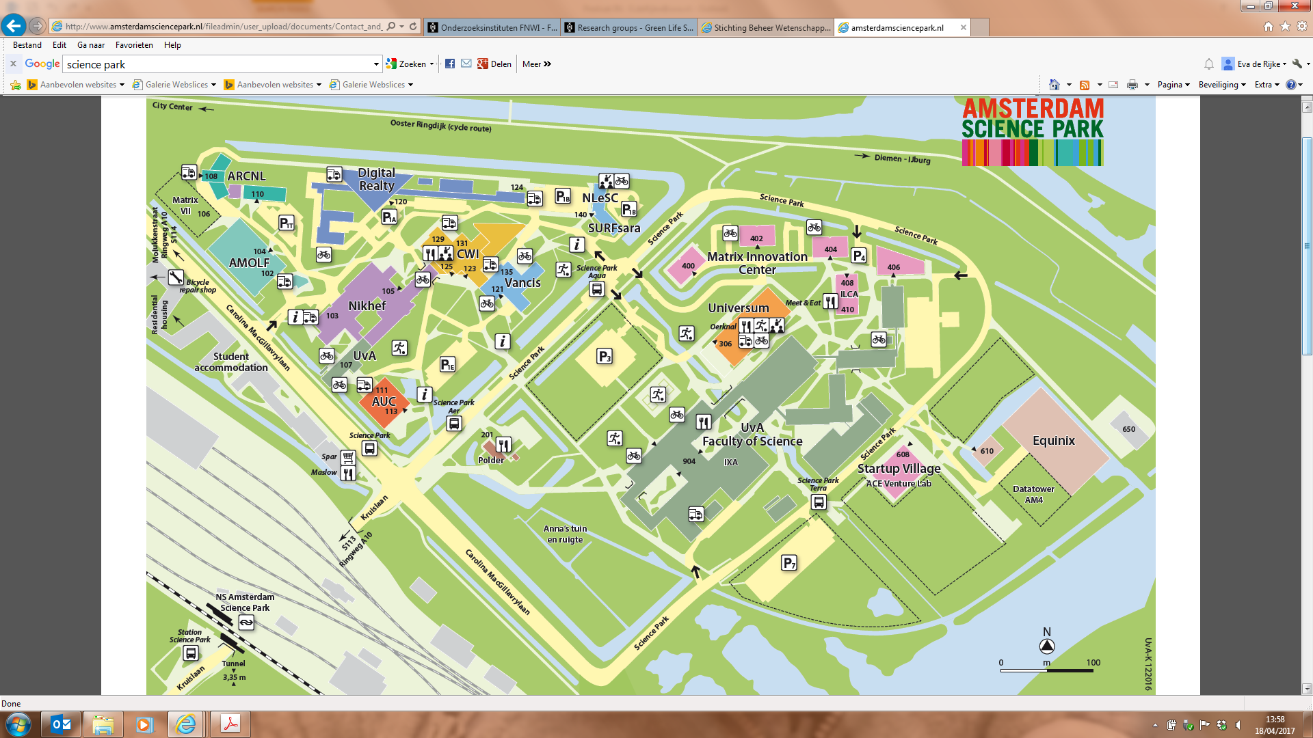

Directions by public transport

By train
Four times an hour a train leaves from Amsterdam Central station or Almere/Zwolle station to station Amsterdam Science Park.
- Timetables Amsterdam Science Park Station
- Trainplanner NS

By subway
Amsterdam Amstel, bus 40 or 240

By tram
From Amsterdam CS tram 9 direction Diemen
Change at stop Kruislaan to bus 40

By Bus
40 from stations Amsterdam Muiderpoort and Amsterdam Amstel
Spitsbus 240 only from Amsterdam Amstel
- Timetables of bus 40 and 240 can be found on the website of GVB

OV-Bike
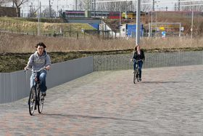
At Amsterdam Amstel station and Muiderpoort station an OV-bike (public transport bike) can be rented. It's takes about 15 minutes to bike to Amsterdam Science Park from both stations.
A large part of Amsterdam, Diemen and Duivendrecht lies within a 7-kilometre radius (20-30 minutes by bike) from Amsterdam Science Park.
To plan your journey by bike, travel to the website of Routecraft for the best directions to Amsterdam Science Park. Note: use Kruislaan 300 instead of Science Park at the adress field! You can plan your route also by using Google Maps

Directions by Car
Amsterdam Science Park is accessible by car. You can park at the civic amenity and plan your route to us by using Google Maps.
- Ring road Amsterdam (A10)
- Exit 'Watergraafsmeer/s113'
- Follow signs 'Science Park'
- On middenweg at Kruislaan turn right
- Follow road through train tunnel
- You have arrived at Amsterdam Science Park
- Now use the map of Amsterdam Science Park (see below)
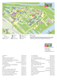

Trucks/busses higher than 3,35 m
- Ring road Amsterdam (A10)
- Exit 'Zeeburg/s114'
- Follow Zuiderzeeweg, Flevoweg, Insulindeweg
- Molukkenstraat, Mac Gillavrylaan

Navigation system
Using a navigation system? The new street name "Science Park" is not yet implemented in many systems. You can use "Kruislaan 300" instead.

Online route planner
Find the quickest or shortest routes to Amsterdam Science Park with the route planner from the ANWB.

Parking
Information about parking

Parking
You can follow the signs to the right car park at Amsterdam Science Park. If a space has been reserved for you, please head to P4. This visitors' car park is located between Science Park 404 and 406. You may also park at the public (paid) car parks P1, P3 or P7. Each company or institute has its own rules with regard to visitors. Visitors are advised to contact the institute or company with which they have their appointment.

Rates, times and rules
An hourly rate of €2.40 and a maximum daily rate apply at the site. It also possible to purchase day passes. Please pay at the parking machines on site or, in the case of employees/companies, via the company to which you are affiliated.
Please note: Cition parking permits, parking passes, day passes and month passes are not valid on this site!
In case of trouble please call: 14020 or 020 624 1111

