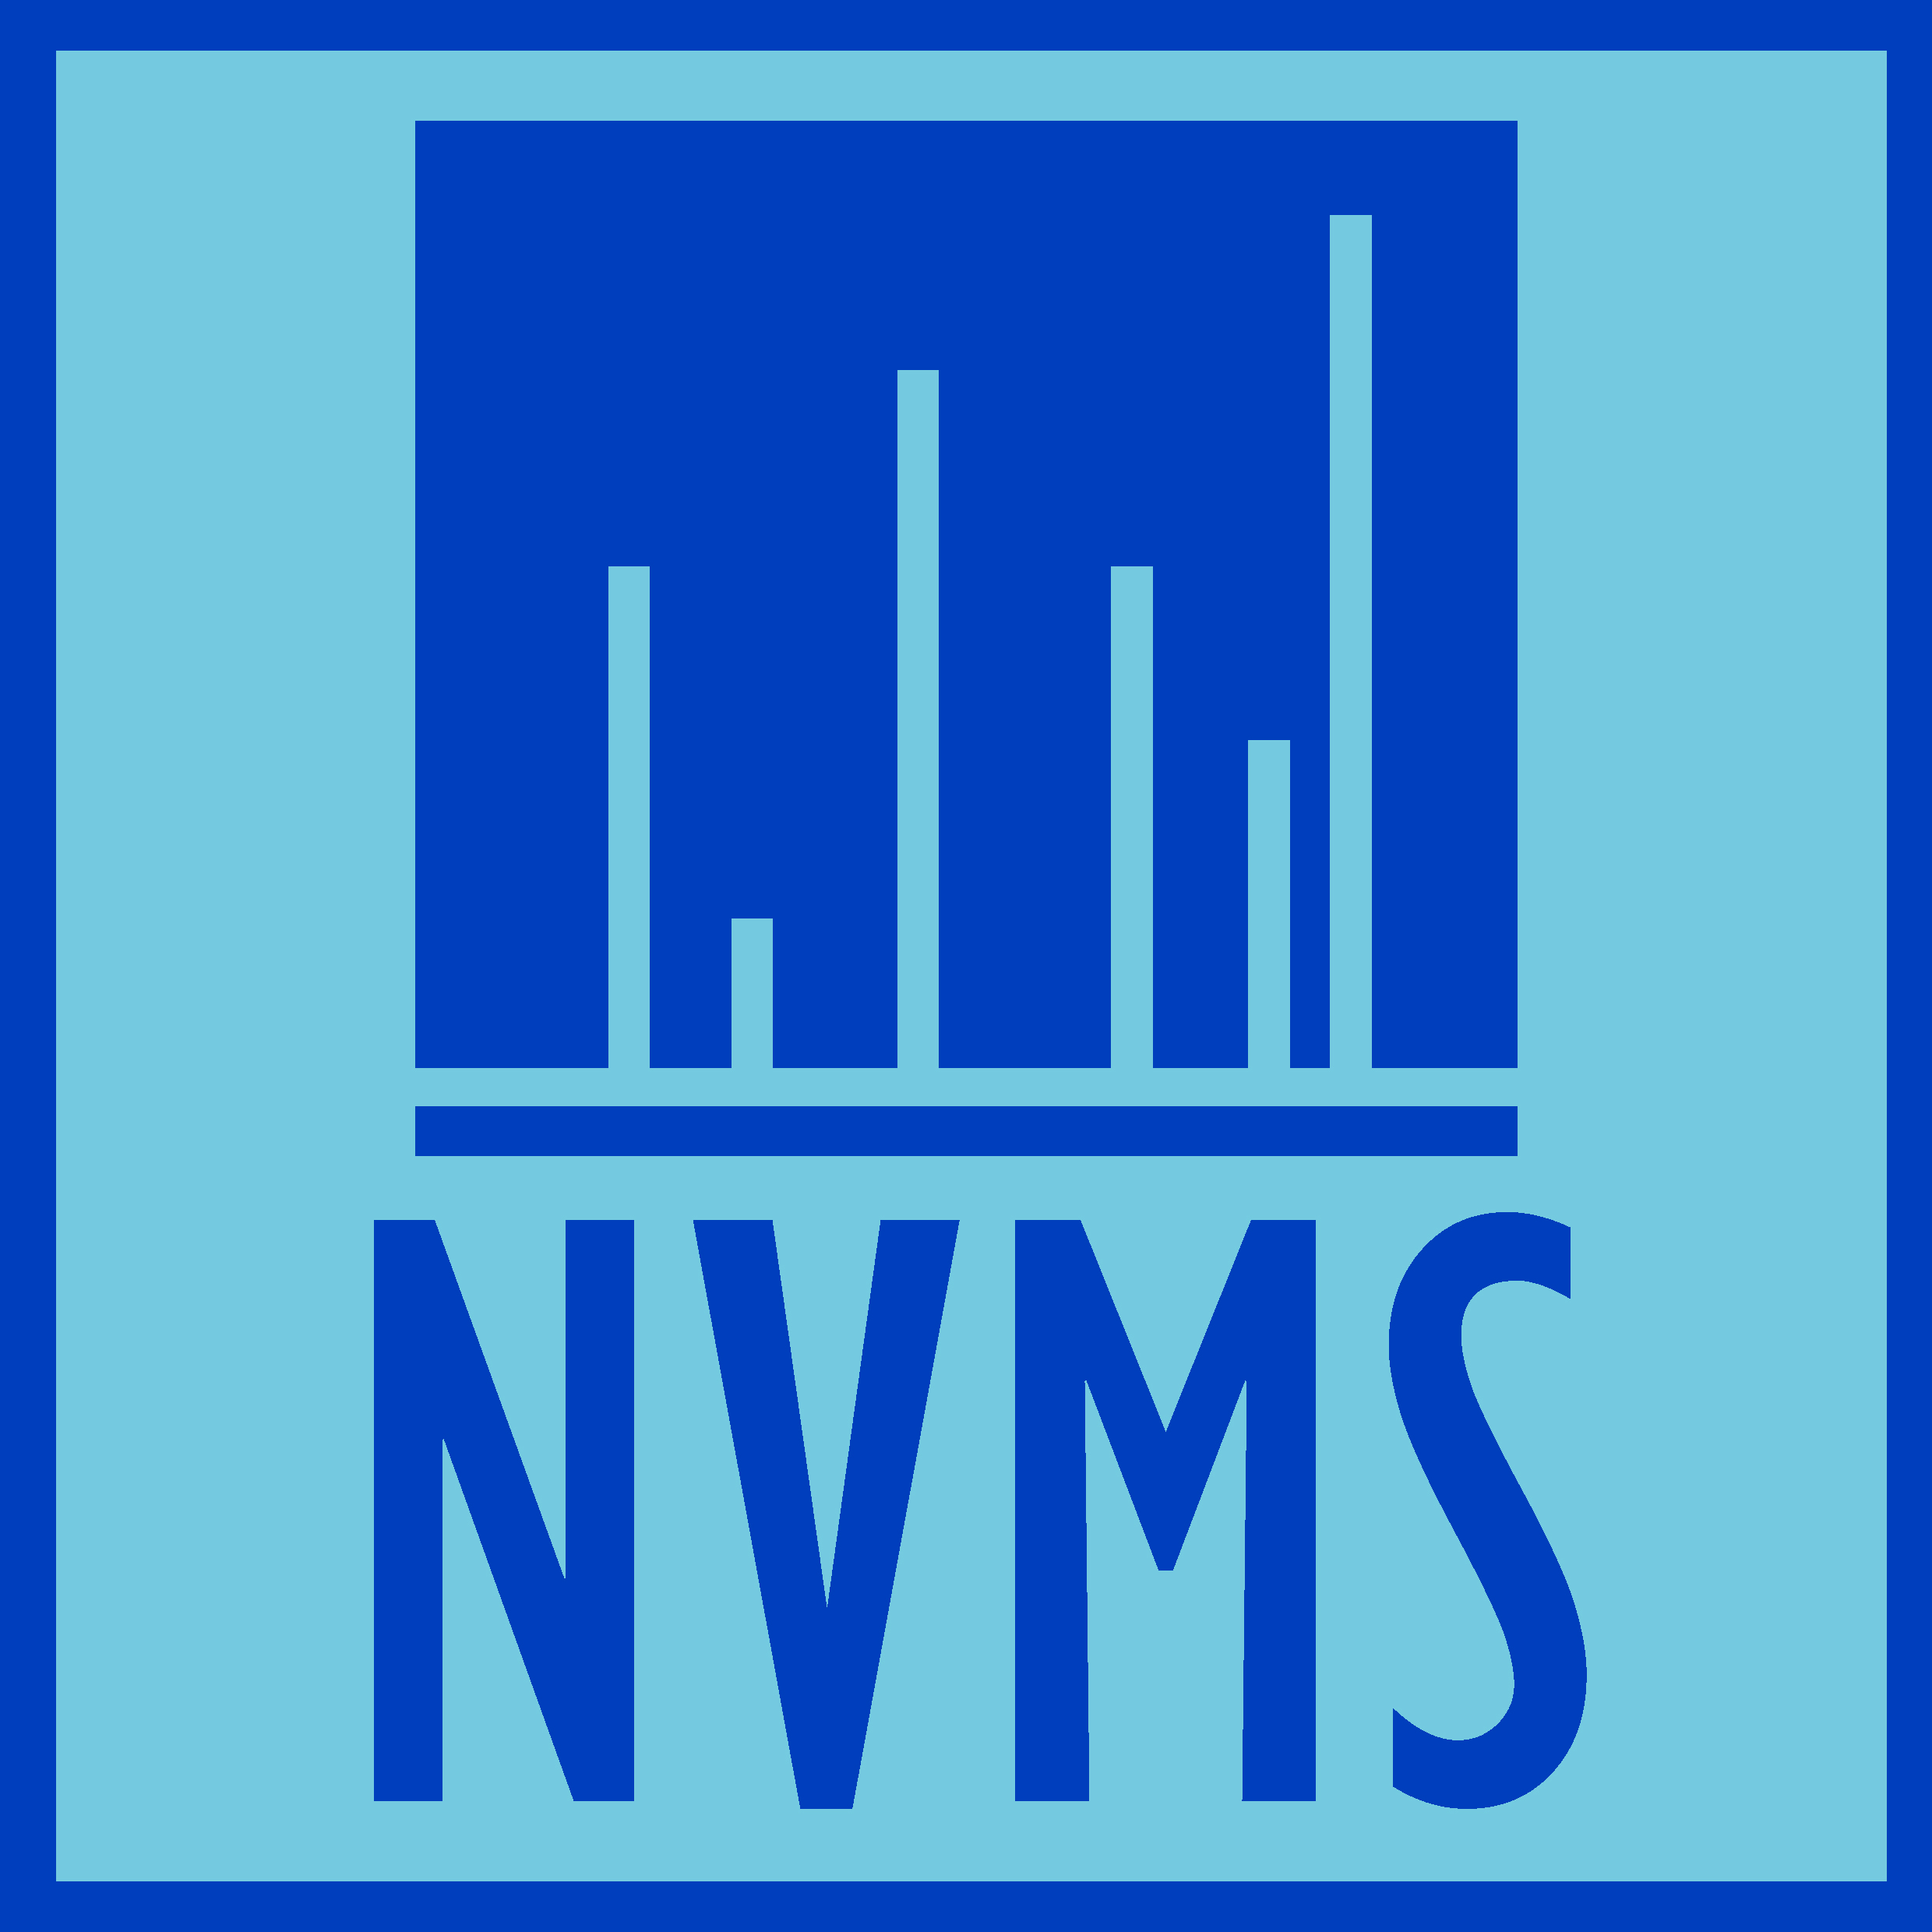

(NV)MS Conference Attendance Fund
Information and conditions

- Purpose
  - Support NVMS members in attending international conferences related to mass spectrometry for presentation of research data (oral or poster).
  - The grant has a value of €1000 and can be used to cover (part of) the conference fee, travel costs, lodging and other travel related costs.

- Who can apply
  - Researchers (BSc, MSc, PhD, Post-doc (until 2 years after obtaining a PhD)) who are members of the NVMS and have at least a 0.5 FTE position in the Netherlands.
  - The requester should be active in this position during conference attendance.
  - The requester can obtain a travel grant only once in his/her career. It is allowed, though, to apply several times as long as the requester has not been awarded an (NV)MS Conference Attendance Fund grant before.

- Procedure
  - General
    - The Board of the NVMS decides each year
      - to open the fund for application;
      - how many grants can be applied for.
  - Request
    - The request for a grant should be send to the secretary of the NVMS (info@nvms.nl).
    - The request can be made for future conference attendance and presentations only and cannot be used for conferences that have occurred in the past.
    - Entries will be reviewed twice a year. Deadlines for submissions are: 30 June and 31 December.
    - Requests can be made for conferences taking place within one year after submission closure.
    - The request should be accompanied by:
      - Accepted (if possible) abstract (1 A4) for oral/poster presentation (max. 750 words).
      - Figures allowed if this clarifies the content of the abstract.
      - Detailed overview of the expected costs (travel, lodging, conference fee, etc.).
      - Proof of official position (of min 0.5 FTE) in NL during time period of the conference attendance (e.g. letter/email supervisor).
  - Review
    - The committee will review the request within 1 month after each deadline.
    - The review will consist of
      - a check whether the request is delivered in full (see above);
      - a scientific review.
    - The outcome of the review & approval or rejection (not open for discussion), will be communicated to the requester via the secretary of the NVMS.
    - Upon grant approval, the requester commits him/herself to a presentation of the poster/oral at either the 1st or the 2nd NVMS meeting following the granted conference.
  - Committee
  - The committee consists of three NVMS members (preferably one from university, one from industry and one from the NVMS board).
  - Committee members will be active for 2 calendar years.
  - The board of the NVMS will announce the members of the committee via the NVMS website (www.nvms.nl).

- Grant payments
  - Payments are based on claimed expenses with a maximum of €1000 per grant.
  - A travel expense form (found on the NVMS website) should be completed.
  - Travel expense forms should be accompanied with original receipts (Xerox copies will not be accepted) and a PDF of the presentation (oral or poster).
  - Please send the form and receipts to the treasurer of the NVMS:
Dr. Maarten Altelaar
Utrecht University
Padualaan 8
3584 CH Utrecht
The Netherlands

